From: https://medium.com/extremetech-access/the-us-air-force-quietly-admits-the-f-35-is-a-failure-7ba0ad251051
Date: 2021 Feb 25

The US Air Force Quietly Admits the F-35 Is a Failure

ExtremeTech
Feb 25 · 5 min read [10 min I'd say + musing time -FNC]
by Joel Hruska

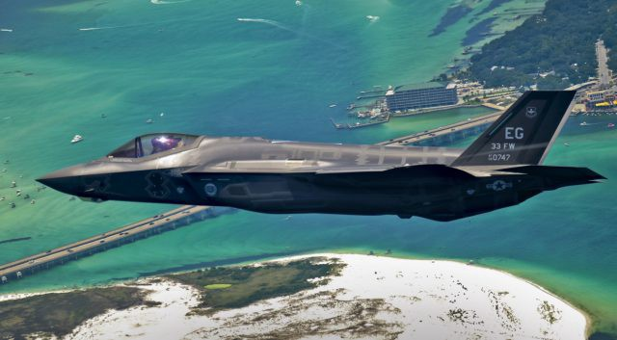
Ιμαγε βψ Σταφφ Σγτ ϑοελψ Σαντιαγο,€ΥΣΑΦ.
The Air Force has announced a new study into the tactical aviation requirements of future aircraft, dubbed TacAir. In the process of doing so, Air Force chief of staff General Charles Q. Brown finally admitted what’s been obvious for years: The F-35 program has failed to achieve its goals. There is, at this point, little reason to believe it will ever succeed.
According to Brown, the USAF doesn’t just need the NGAD (Next Generation Air Dominance) fighter, a sixth-generation aircraft — it also needs a new, “5th-generation minus / 4.5th-generation aircraft.” Brown acknowledged some recent issues with the F-35 and suggested one potential solution was to fly the plane less often.
“I want to moderate how much we’re using those aircraft,” the general said. “You don’t drive your Ferrari to work every day, you only drive it on Sundays. This is our high end, we want to make sure we don’t use it all for the low-end fight… We don’t want to burn up capability now and wish we had it later.”

Ferrari Would Not Consider This Comparison a Compliment
These statements may not seem provocative, but they represent a huge shift in the Air Force’s stance regarding the F-35. The F-35 originated from what was originally known as the Joint Strike Fighter (JSF) program, a multi-national development effort between the United States, the UK, and multiple other partner nations. The explicit purpose of the JSF program was to create a single aircraft that could replace a wide range of air, ground, and strike fighter capabilities. Today, the F-35 exists in three variants.
- The F-35A provides conventional takeoff/landing and is operated by the USAF,
- the F-35B provides short-takeoff and vertical-landing (STVOL) capabilities for the US Marines, and
- the F-35C is designed for carrier operations and is operated by the US Navy.
[Reviewing Joint Strike Fighter (JSF) program , one sees that this F-35 program was initiated in the late 20th century and is an exemplar of what often happens in our military-industrial complex in the early 21st century. – On My Watch, FNC]
The DoD and Lockheed-Martin have spent years painting the F-35 as a flexible, multi-role aircraft capable of outperforming a range of older planes. The rhetoric worked. The F-22 Raptor, F/A-18 Hornet, and several jets in the Harrier family were retired because the F-35 was supposed to replace them. The Air Force fought to replace the beloved A-10 Warthog with the F-35 on the grounds that the latter was, somehow, a superior replacement.

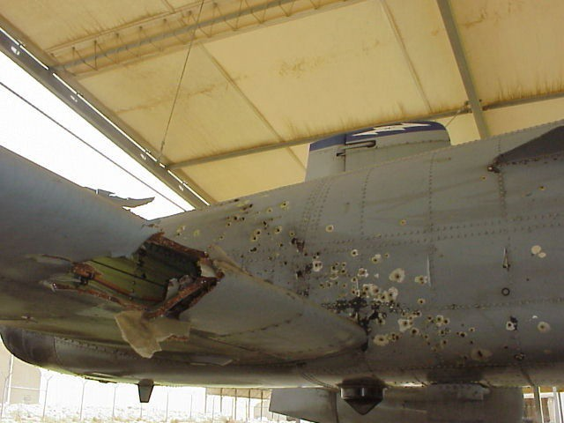
This jet flew home. The F-35 has not proven itself to be equivalently robust. Image by USAF.
The F-16 was supposed to be replaced by the F-35. Back in 2010, Lockheed expected the F-35 to replace the F-15C/D variants as well as the F-15E Strike Eagle. That’s six different aircraft covering all three roles (air-to-air, strike, and ground). The F-35 was explicitly developed and designed to be a flexible, effective, and relatively affordable aircraft with sophisticated logistics management systems that would reduce downtime and boost reliability.
This aircraft wasn’t supposed to be a Ferrari. It was billed, explicitly, loudly, and repeatedly, as the single platform that could fill any mission requirement and satisfy virtually any mission profile outside of something a B-52 might handle. Instead, the Air Force, Marines, and Navy have all adjusted plans at various times to keep older aircraft in service due to delays and problems with the F-35.
To say the F-35 has failed to deliver on its goals would be an understatement.
- Its mission capable rate is 69 percent, below the 80 percent benchmark set by the military.
- 36 percent of the F-35 fleet is available for any required mission, well below the required 50 percent standard.
- Current and ongoing problems include
- faster than expected engine wear,
- transparency delamination of the cockpit, and
- unspecified problems with the F-35’s power module.
The General Accountability Office (GAO) has blamed some of this on spare parts shortages, writing:
[T]he F-35 supply chain does not have enough spare parts available to keep aircraft flying enough of the time necessary to meet warfighter requirements. “Several factors contributed to these parts shortages, including F-35 parts breaking more often than expected, and DOD’s limited capability to repair parts when they break.
There have been so many problems with the F-35, it’s difficult even to summarize them. Pilot blackouts, premature part failures, software development disasters, and more have all figured in various documents over the years. Firing the main gun can crack the plane. The Air Force has already moved to buy new F-15EX aircraft. Multiple partner nations that once promised F-35 buys have shifted orders to other planes. The USAF continues to insist it will purchase 1,763 aircraft, but the odds of it doing so are increasingly dubious. The F-15EX costs an estimated $20,000 per hour to fly. The F-35 runs $44,000. Lockheed-Martin has promised to bring that cost down to $25,000, but it’s been promising that for years. Former Air Force pilots have not been kind in their recent evaluations of the aircraft’s performance and capabilities.
Brown indicated he’s not interested in buying more F-16s, because not even the most advanced variants have the full scope of features the USAF hopes to acquire. This would presumably also disqualify the “F-21” Lockheed-Martin recently announced for the Indian market. Instead, Brown wants to develop a new fighter with fresh ideas on implementing proven technologies.
Congress will have a voice in this discussion, so it’s far from a done deal, but after over a decade mired in failure, someone at the DoD is willing, however quietly, to acknowledge that the F-35 will never perform the role it was supposed to play. As for how much it’ll actually cost to build that 4.5th-generation fighter, all I’ll say is this: The F-35 was pitched to Congress and the world as a way of saving money. Today, the lifetime cost of the aircraft program, including R&D, is estimated to be over $1.5 trillion. The price of a supposedly cheaper 4.5-generation plane could easily match or exceed the F-35’s flyaway cost by the time all is said and done, though hopefully any future aircraft would still manage to offer a much lower cost per hour.
Now Read:
- The F-35 Is Still Broken and the F-35A Can’t Shoot Straight
- New Report Finds Pentagon Weapon Systems Riddled With Vulnerabilities
- US Air Force Considers Cutting F-35 Orders By a Third
Originally published at https://www.extremetech.com on February 25, 2021.

